Software requirement specifications

For

<SMS server in communication system>

Version 1.0 approved

Prepared by<batch 2>

<RMKEC>

<01.12.2022>

Table of content

1. Introduction

1.1 Document Conventions

1.2 References

2. Overall Description

3. System Features

4. External Interface Requirements

4.1 User Interface

5. Other Nonfunctional Requirements

1.INTRODUCTION

Defines mobile Applications as software designed to take advantage of mobile technology. In this paper we specifically refer to Mobile Applications as SMS Based Mobile Application (M-Services). This way we put a distinction of M-Service from more complex and advanced Mobile Applications that run on smartphones. The reason to do this is that, although mobile phones are widely spread in low and mid income countries, the majority of people, especially in low income countries, own basic phones which have limited features compared to smartphones.

1.1 document convections

Unstructured Supplementary Service Data

Conceptual Data Modelling

USSD code format

USSD communication is initiated by dialing a specialcode. USSD codes comprise of asterisk (*), followed by acombination of digits (0 to 9) and a hash (#) Example

*150*00#. The * and # codes are used to signify thebeginning and end of the request.

1.2 reference

[1] M. Facemire, J. McCarthy, and T. Schadler. (2013). Mobile Needs

A Four-Tier Engagement Platform. Available:

http://blogs.forrester.com/print/ted_schadler/13-11-20-

mobile_needs_a_four_tier_engagement_platform

[2] A. Dennis, B. H. Wixom, and R. M., "Systems analysis and

design," 5 ed: John Wiley & Sons, Inc., 2012, p. 104.

[3] J. S. Valacich, J. F. George, and J. A. Hoffer, Essentials of Systems

Analysis and Design, 5 ed. New York: Pearson, 2012.

[4] M. J. Albers and M. B. Mazur, Content and Complexity:

Information Design in Technical Communication: Taylor &

Francis, 2014.

2.Overall description

2.1 product features

Conceptual Data Modelling

[16] describes conceptual data modelling as a way of representing organizational (Information Systems) data. The goal of data modelling is to show as many rules about the meaning and interrelationships among data as possible, independent of any database management system (e,g MySQL, Oracle, MS SQL, SQLite). The common tool that is used to model the data are Entity- relationship (E-R) data models. These are diagrams that show how data are organized in an information system. ERD uses a special notation of Rectangles (to describe entities), diamonds (to describe relations), and lines to represent as much meaning about data as possible. The deliverable from the conceptual data-modeling step within the analysis phase is an ERD Diagram During the analysis of requirements for our M-Health we had put focus on data to gain the perspective on data needed to develop a data model. The following entities have been identified; (1) USER_GROUP (Defines roles of users e.g Doctors, Administrator), (2) USER (Handles users’ profile data), (3) SUBSCRIBER (Stores subscribers information) , (4) QUESTION (Stores posted questions), (5) ANSWER (stores responses to questions),

(6) CATEGORY (Stores categories of information which forms menus and submenus), (7) CONTENT (Stores information that subscribers can access),

(8) RECEIVED_SMS, (9) SPONSOR (Stores sponsors information), (10) ADS (Stores all the advertisements)

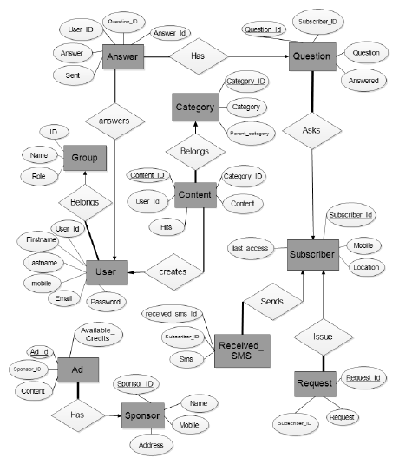

3.system requirements

Functional Requirements

Functional requirements are those requirements that are used to illustrate the internal working nature of the system. They describe what tasks the system should perform.

a) Subscribers

• Subscribes

• Send questions

• Access Information via mobile phone

b) Administrator

• Manage Doctors

• Monitor Subscribers

• Manage Sponsor Information

• Access Information

4.external interface requirements

4.1 user interface

All end users (Subscribers) of the system will access the system via their mobile phones. The system is designed to work for all types GSM of phones. Error! Reference source not found. Shows a summary of user actions when accessing our M-Health application via the mobile phones. The flow of actions is numbered from 1 to 12. (1) User enters the USSD code to access information in this case it is *31022, (2) If the user is accessing the system for the time he will be asked to subscribe by sending a messages to a special number (registration could free or onetime payment of 250Tsh). (3) Once in the system the user will receive a USSD message informing him that the service is free but he will receive an ad. (4) User can then choose to proceed or quit. (5) Upon agreeing to continue a menu of information categories will be presented.(7) More submenus will be presented for user to narrow down his choice. (9) After reaching to the last subcategory, user will receive a USSD SMS informing him that information will be sent to his phone as an SMS. (10) User will then receive an advertisement with a code that he will have to send to the system via USSD. Sending of this code is a way of making sure that at least the user read the Ad SMS. (12) Lastly the requested information.

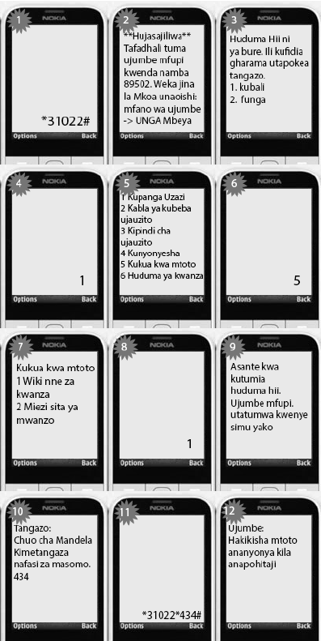

Web interface Design

Both system administrator and the doctors will access the systems by using a web interface. This way they will be able to add and manage new users and manage new content respectively.

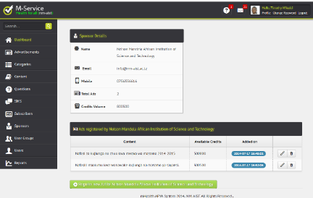

5. other non functional requirement

a) Operational

• USSD/SMS service

• The system should interface with SQL database.

b) Maintainability & Upgrades

• System should allow upgrade to smartphone usage

• System should allow updates and upgrades without affecting users’ experience

c) Acceptance

• System Language should be Swahili

These are a summary of all requirements that as a developing side we have come up with. It is of course true that some or most of these requirements will change overtime as users will require some aspect of the systems to be improved, added, or dropped. There is at all-times a call for better future versions of the system and services.